**Love-15: Character Development through Teen Tennis**

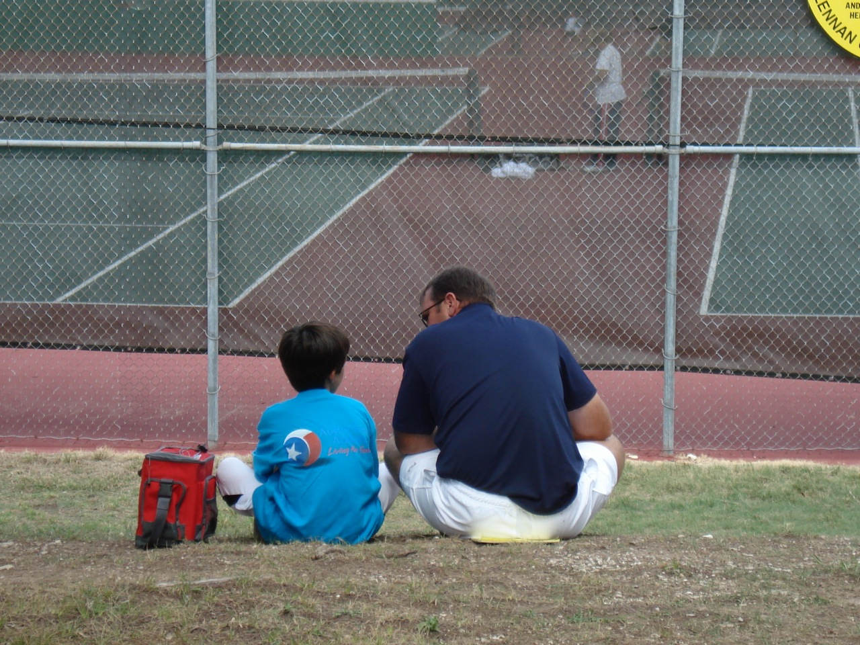

**Scott Hannon**

**H611B: Moral Adults/Moral Children**

**Professor Rick Weissbourd**

**Harvard Graduate School of Education**

**April 27, 2011**

Welcome parents! My name is Scott Hannon, or “Coach Hannon”. It’s a pleasure and an honor to be here with you.I hope today will mark the beginning of a friendship in which you feel you can speak authentically with me about our tennis coaching program, your child, their development, and related matters. I wish to discuss my “Coaching Tennis for Character” philosophy, which may be unfamiliar to you. Many aspects of team tennis can be bridges to supporting moral reasoning and character development in students. I will help build that bridge this year, and as parents you are in an ideal situation to partner with me in this endeavor. Feel free at any time to ask questions or share related useful and relevant insights.

There is a lot of evidence that kids on sports teams thrive best and develop character in a *mastery-oriented achievement climate*,as opposed to an ego-motivating *performance climate*. As a coach, I will help foster mastery climates by providing a structured environment, and communicating in a way that focuses on *relationship* and *process*,as opposed to *results*. I’ll ensure that tennis practice activities are varied and diverse. Authority will, to a large degree, be shared; recognition will focus on effort; and groupings for drills will be varied (Shields & Bredemeier, 2005).

Visualize character as a circle with *moral conviction* at its *center*. The capacity to *expand* that “circle of character” depends on psychological competencies, orientations and attributes that *mediate* between those moral convictions and *how they are lived out in action (*Shields & Bredemeier, 2005). In sports parlance, this can be restated as “walking the walk, not just talking the talk”. Another way of looking at moral capacity and character is that it starts with “good” and goes toward “right”. It is one thing to have the moral capacity to determine the good in a person or situation. It is quite another to take “right action” in a variety of different contexts; character develops over time when you apply what is good in a variety of scenarios over time. Of course we don’t always get it right, but through self-reflection and accepting feedback from fellow teammates, coaches, and parents, we can eventually fine tune our internal compass to point toward right action. Just as lots of practice, patience and determination helps us to hit the ball exactly where we want it to go, doing the right thing (and thus building character) requires similar practice, patience and determination.

Many aspects of the tennis program this year will play a role in the character development in your kids.

Greek culture, which brought us the Olympics, also played a huge role in bringing us democratic principles. The tennis team this year will be run like a democracy. Within reason, I will ask students to co-construct rules and co-determine sanctions for rule violations on our team, with an emphasis on accentuating the moral dimensions of playing tennis. I’ll encourage players to develop shared norms that express and realize the ideals of cooperation, fair play, and respect for opponents and officials. I will encourage utilizing the democratic skills of self-expression, listening, and deliberation toward the team’s goal of serving the “common good” (Shields & Bredemeier). Since the development of a democratic mindset generally improves with age and experience, your support as parents in their understanding of such a democracy will make a big difference. I encourage you to explore democratic principles with your children by engaging with them on the topic when it comes up in Social Studies class and exploring ways it relates to making decisions and relating in your own home.

We will talk a lot this year about what it means to be the kind of team that supports the *improvement* of *all* players. During practice, tennis players sometimes hit dramatic, flashy shots for their own ego satisfaction, rather than structure their practice around improving the conditioning and skills of *both* practice partners. I will encourage students to converse with their practice partners about the *purpose* of their workouts and encourage them to authentically express what they want and need from each other in practice. The “right” practice routines will be those that both improve tennis skills *and* enhance the experience of team unity and community. As parents, you can support the character of your kids by focusing on mutual improvement when you play tennis with them, or even when you engage with them in other areas of their lives. Supporting each other’s improvement is usually a deeply fulfilling and meaningful experience for kids.

I’ll encourage players on the team to honor each other and respect each other’s differences.Suppose a new member of the team comes from a different country and does not understand the rules, standards and/or mores of tennis as well as the native students do. Now imagine that some of our students feel this new member is a handicap to the team and they proceed to make fun of him or her. As a coach, I will engage the team in moral reasoning questions such as: “What do you think it’s like to come to a new country, to play a game you’re not familiar with, or is played differently in this country? What do you think it feels like to have teammates talking or screaming at you in a language you don’t understand?” (Weissbourd, 2009). Turning these moral aspects into questions not only helps with developing empathy, perspective-taking and other moral capacities, but also empowers the new player to reach his or her potential and give back to the team in ways we could not imagine, increasing the sense of character on the team.

I will coach and guide our tennis team members to appreciate players on opposing teams both during and after play, no matter the outcome. I will explain the moral benefits of graciously shaking hands with opponents and linespeople, even if a player disagrees with an event from the match. I will talk to them about separating linespeople’s and opponents’ *calls* from *them as human beings*. I will encourage tennis team members to “appreciate the enemy,”an ethical principle highly encouraged in many spiritual philosophies.Players will learn to notice how quickly their minds bounce back and forth between making “the other” out as an enemy and making them out as a friend, a practice instrumental in decelerating aggression. In the context of tennis, a powerful deterrent to violating another human being is recognizing that our hostile feelings toward another person arises within the context of the match, and rarely has anything to do with the opponent (Weissbourd, 2009). It is one thing to say “it’s just a game” and another to truly *feel it* and *embody it* during sometimes-trying circumstances.

Competition can help students “bump up against” the intensity of others’ feelings and the intensity of their own feelings (Weissbourd, 2009). Our “feelings landscape” is quite complex and it is helpful to be comfortable and knowledgeable about its “square footage” and “peaks and valleys.” Together, we will make the tennis team a safe context in which to explore that terrain. Tennis provides many opportunities to experience, name, and manage emotions, such as the shame that often arises from losing and the anger felt when a shot does not land where we wish it to land (Weissbourd, 2009), or when we feel cheated on a call. Please support your kids in becoming more intelligent with their emotions. I’ve arranged to have copies of Daniel Goleman’s wonderful and readable book *Emotional Intelligence* sent to the school so that each player and family can have a copy if you want one.

Tennis team will be an opportunity to have real and authentic conversations. Players often discuss aspects of their lives in informal settings such as bus trips to other schools (Weissbourd, 2009). I will provide a safe setting for the discussion of these topics together as a team. We will not have formal kinds of discussions, or lectures, which are better suited to trained school counselors and psychologists. Rather, as a team, we will talk about these topics in the context of what they mean to developing character, both on the tennis court and in their lives. These kinds of discussions will enhance the sense of trust amongst teammates, support broader community-building and ideally result in the development of athletic capacity. Please use tennis as one of the many opportunities to enter into conversations about other aspects of your children’s lives and soon they will associate tennis with connection and happiness. Note that tennis *itself* is *like a conversation*, in that it involves a “back-and-forth” dynamic.

I encourage you and your child to appreciate some of the humor that can accompany sports. I try to help kids get perspective and chuckle about how anxious, serious, and angry we can all get about winning. Sports is similar to theater in the sense that an irony exists in the particular zone between real life and a game; the game both means a great deal and also does not mean anything at all (Weissbourd, 2009). When parents laugh with their children, it helps them to develop a humor and lightness that can contribute to character development.

Tennis is a wonderful opportunity to connect with people from different schools, towns, regions, family backgrounds and ethnicities. Sports is sometimes the only arena where children have an opportunity to develop friendships and understandings of others across race, ethnicity, and class boundaries (Weissbourd, 2009). Sports can model teamwork, but also can contribute to clique behavior. We will work to avoid cliques. The strong sense of team will help players notice destructive clique behavior (as opposed to healthy community-forming behavior), both on the team *and in their classes at school.*  Parents can model this for them, so please encourage the ethic of inclusion with your kids in other areas of their lives and allow character to blossom.

As parents, we often *say* that winning does not matter, but our actions often do not reflect this. Some parents are extremely attached to their kid’s winning. This can send a message of confusion as well as hypocrisy and inauthenticity to our kids, who have trouble making sense of mixed messages (Weissbourd, 2009). Be extremely careful to *not* make their tennis experience *about you*. Put your *own child’s interests first*!Please also be aware that many of you may experience a kind of loss *yourself* when your kids lose. Ask yourself what this is about. For some parents, these emotions sometimes unconsciously remind you of other aspects in your lives, such as work pressures or the memory of your own sports losses as a youth. Some parents push sports because they feel it is the only way their child can get into a good college (Weissbourd, 2009). Many parents even experience their child’s winning as a “mood boost” for them. Sports can be an addictive narrative for many parents in same way that certain books, movies, and TV series can be addictive. Some parents, when totally honest, report that at the end of their kid’s season they wonder what they are going to do with themselves. Some kids even continue to play *for their parents.* In these scenarios, kids risk developing the subconscious feeling that *excelling* is the *only way they can find love* from their parents (Weissbourd, 2009), as Andre Agassi expressed in his book *Open.* Some of the warning signs of this destructive mindset are if parents say “we” won a game, if dinner conversation tends to center around sports, and if you plan family vacations around sporting events. Please be aware of your own issues and the impact they may have on your kids.

Please don’t hesitate to communicate with me. I want to hear from you and get to know you. You might have concerns that your child is feeling excluded, degraded, or bullied by other students. You may want to speak up about your child’s role on the team in some other way. My door is always open. Join me this year in making tennis a journey in your player’s character development.

Thank you,

Coach Hannon

References

Shields, D.L. and Bredemier, L.B. (2005). Can sports build character? In Lapsley, D.K. and Power, F.C. (Eds.), *Character psychology and character education* (pp. 121‐139). Notre Dame, IN: Notre Dame University Press.

Weissbourd, Richard (2009). *The parents we mean to be: How well intentioned adults undermine children's moral and emotional development*. Boston, MA: Houghton Mifflin Harcourt.